from ast import increment_lineno

import pandas as pd

import numpy as np

from nltk.tokenize import sent_tokenize,word_tokenize

from sklearn.feature_extraction.text import CountVectorizer

from sklearn.model_selection import train_test_split

from sklearn.svm import SVC

from sklearn.datasets import fetch_20newsgroups

from nltk.corpus import stopwords

import string

from nltk import pos_tag

from nltk.stem import WordNetLemmatizer

from sklearn.feature_extraction.text import TfidfVectorizer

from sklearn.naive_bayes import MultinomialNB

from sklearn.ensemble import RandomForestClassifier

from sklearn.svm import SVC

import pandas as pd

from sklearn.model_selection import train_test_split

from sklearn import preprocessing

import seaborn as sns

import matplotlib.pyplot as plt

%matplotlib inline

import nltk

nltk.download('stopwords')

data=pd.read_csv("/content/twitter_training.csv")

v_data=pd.read_csv("/content/twitter_validation.csv")

data

data.columns=['id','game','sentiment','text']

v_data.columns=['id','game','sentiment','text']

data

v_data

data.shape

data.columns

data.describe(include='all')

id_types=data['id'].value_counts()

id_types

plt.figure(figsize=(12,7))

sns.barplot(y=id_types.index,x=id_types.values)

plt.xlabel("type")

plt.ylabel("count")

plt.title('# of id vs Count')

plt.show()

game_types=data['game'].value_counts()

game_types

plt.figure(figsize=(14,10))

sns.barplot(x=game_types.values,y=game_types.index)

plt.title('# of games and their count')

plt.ylabel('type')

plt.xlabel('count')

plt.show()

sns.catplot(x='game',hue='sentiment',kind='count',height=10,aspect=3,data=data)

sns.heatmap(data.isnull(),yticklabels=False,cbar=False,cmap="viridis")

total_null=data.isnull().sum().sort_values(ascending=False)

percent=((data.isnull().sum()/data.isnull().count())*100).sort_values(ascending=False)

print('total records=',data.shape[0])

missing_data=pd.concat([total_null,percent.round(2)],axis=1,keys=['total missing','In Percent'])

missing_data.head(10)

data.dropna(subset=['text'],inplace=True)

total_null=data.isnull().sum().sort_values(ascending=False)

percent=((data.isnull().sum()/data.isnull().count())*100).sort_values(ascending=False)

print('total records=',data.shape[0])

missing_data=pd.concat([total_null,percent.round(2)],axis=1,keys=['total missing','In Percent'])

missing_data.head(10)

train0=data[data['sentiment']=="Negative"]

train1=data[data['sentiment']=="Positive"]

train2=data[data['sentiment']=="Irrelevant"]

train3=data[data['sentiment']=="Neutral"]

train0.shape,train1.shape,train2.shape,train3.shape

train0=train0[:int(train0.shape[0]/12)]

train1=train1[:int(train1.shape[0]/12)]

train2=train2[:int(train2.shape[0]/12)]

train3=train3[:int(train3.shape[0]/12)]

train0.shape,train1.shape,train2.shape,train3.shape

data=pd.concat([train0,train1,train2,train3],axis=0)

data

id_types=data['id'].value_counts()

id_types

plt.figure(figsize=(12,7))

sns.barplot(x=id_types.values,y=id_types.index)

plt.xlabel("type")

plt.ylabel("count")

plt.title("#of id vs count")

plt.show()

game_types=data['game'].value_counts()

game_types

plt.figure(figsize=(12,7))

sns.barplot(x=game_types.values,y=game_types.index)

plt.xlabel("type")

plt.ylabel("count")

plt.title('# of tv shows vs movie')

plt.show()

sentiment_types=data["sentiment"].value_counts()

sentiment_types

plt.figure(figsize=(12,7))

plt.pie(x=sentiment_types.values,labels=sentiment_types.index,autopct='%.1f%%',explode=[0.1,0.1,0,0])

plt.title("the difference in the type of contents")

plt.show()

sns.catplot(x="game",hue="sentiment",kind="count",height=7,aspect=2,data=data)

from sklearn import preprocessing

label_encoder=preprocessing.LabelEncoder()

data["sentiment"]=label_encoder.fit_transform(data["sentiment"])

data["game"]=label_encoder.fit_transform(data["game"])

v_data["sentiment"]=label_encoder.fit_transform(v_data["sentiment"])

v_data["game"]=label_encoder.fit_transform(v_data["game"])

data=data.drop(['id'],axis=1)

data

data.nunique()

v_data.nunique

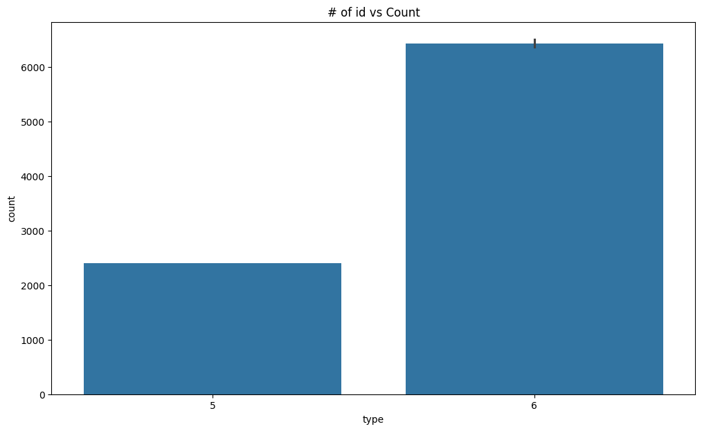

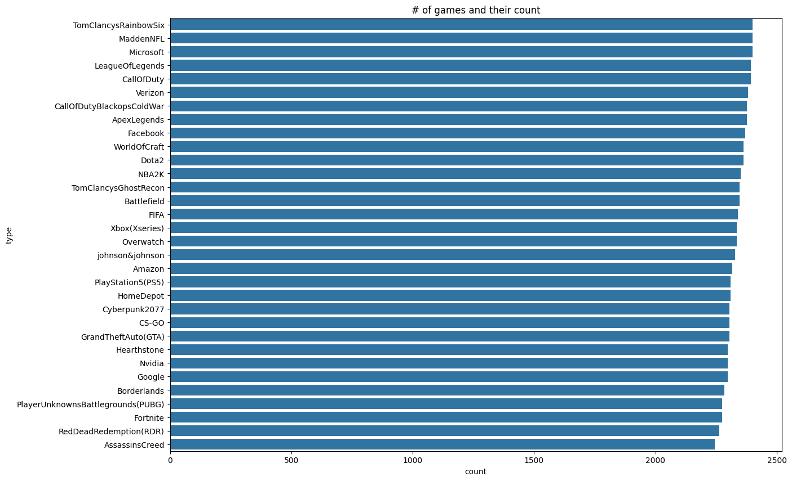

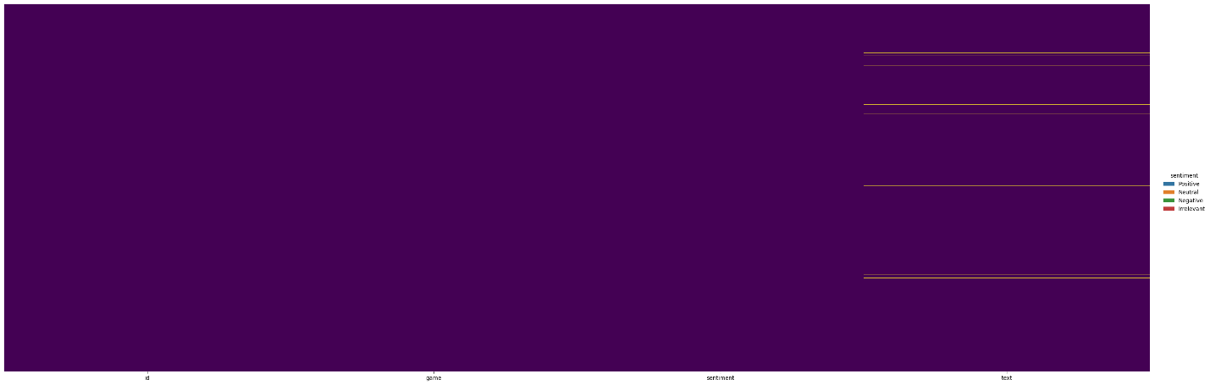

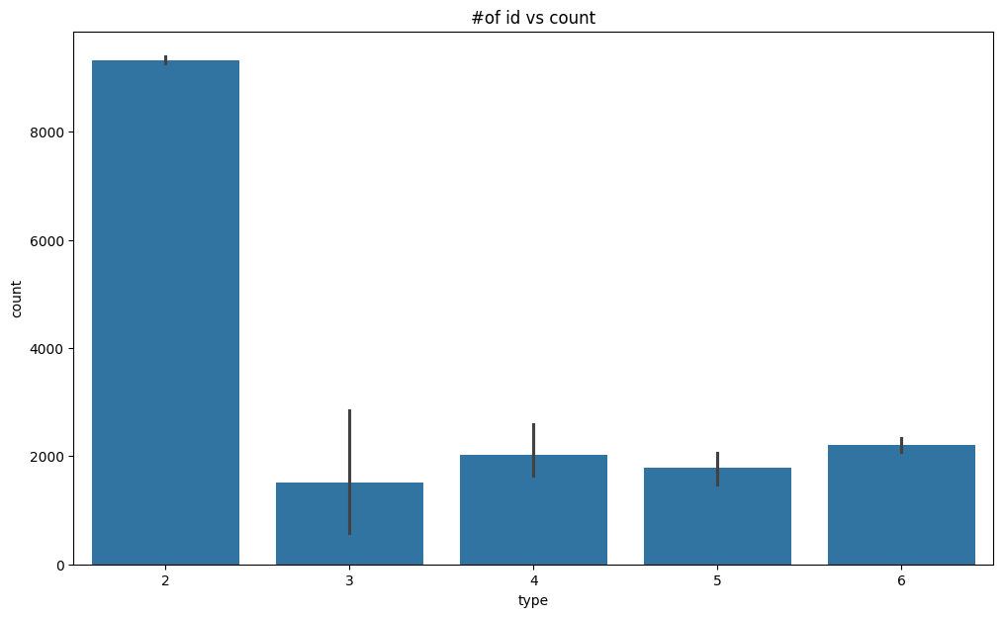

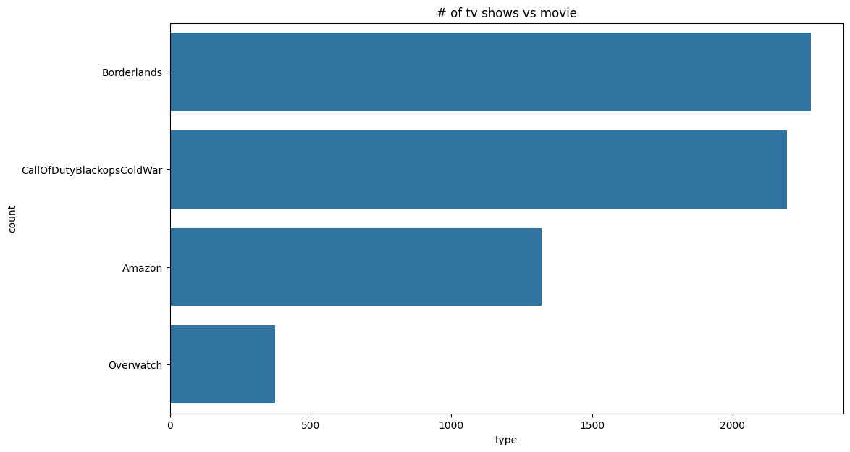

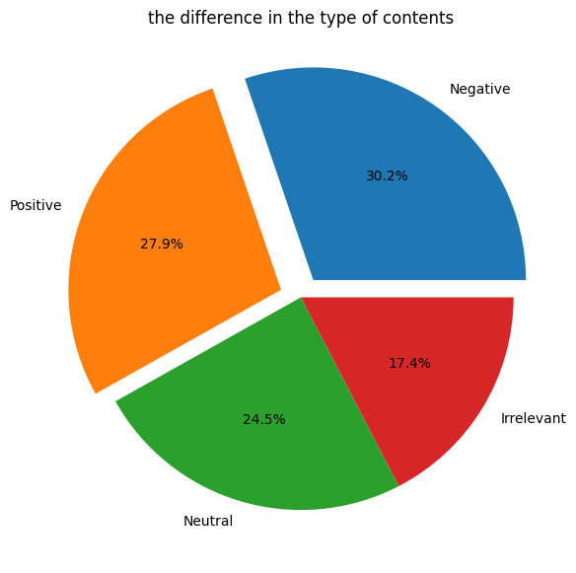

**0id 999**

**Game 32**

**Sentiment 4**

**Text 998**

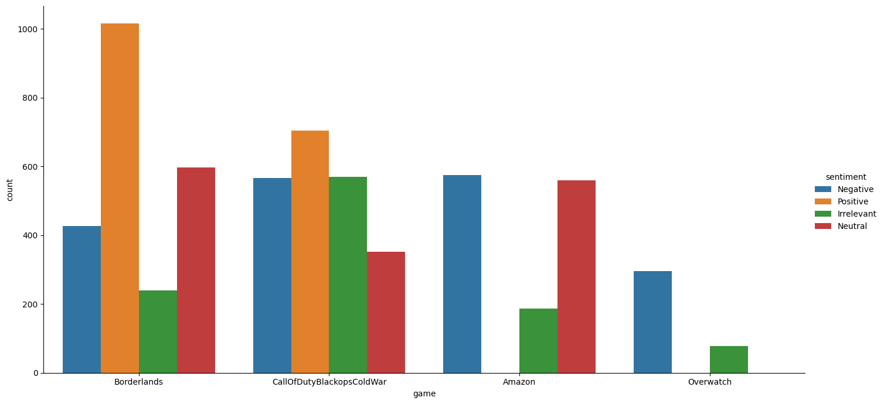

0id999game32sentiment4text998